Data cleaning

*DF*=dataFrame.na.drop() // Removing null rows

Before

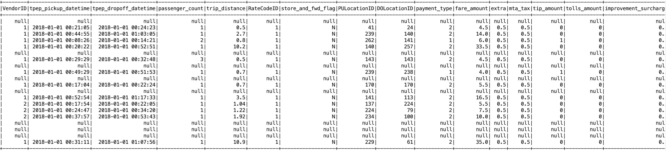

After data cleaning

**

Transformation

Find the peak time of pickup/drops on a daily basis. Consider peak time to be interval of 1 hour.

*pickupDF*=*sparkSession*.*sqlContext*.sql(**"SELECT tpep_pickup_datetime AS datetime, count(*) AS PUcount FROM tempTable GROUP BY tpep_pickup_datetime"**).cache()  
  
*pickupDF*.createOrReplaceTempView(**"tempTable1"**)  
  
*pickupDF*=*sparkSession*.*sqlContext*.sql(**"""SELECT hour(from_unixtime(unix_timestamp(datetime, "YYYY-MM-DD hh:mm:ss ") ) ) as hours,  
 count(PUcount) as pickup_count from tempTable1 group by hour(from_unixtime(unix_timestamp(datetime, "YYYY-MM-DD hh:mm:ss ") ) )  
"""**).cache()  
 *dropoffDF* =*sparkSession*.*sqlContext*.sql(**"SELECT tpep_dropoff_datetime AS datetime, count(*) AS PUcount FROM tempTable GROUP BY tpep_dropoff_datetime"**).cache()  
  
  
*dropoffDF*.createOrReplaceTempView(**"tempTable1"**)  
  
*dropoffDF*=*sparkSession*.*sqlContext*.sql(**"""SELECT hour(from_unixtime(unix_timestamp(datetime, "YYYY-MM-DD hh:mm:ss ") ) ) as hours,  
 count(PUcount) as drop_count from tempTable1 group by hour(from_unixtime(unix_timestamp(datetime, "YYYY-MM-DD hh:mm:ss ") ))  
 """**).cache()  
  
  
*DF*=*pickupDF*.join(*dropoffDF*,*pickupDF*(**"hours"**)=== *dropoffDF*(**"hours"**)).drop(*dropoffDF*(**"hours"**)).cache()  
*DF*.createOrReplaceTempView(**"tempTable"**)  
*sparkSession*.*sqlContext*.sql(**"""SELECT max(pickup_count), min(drop_count) FROM tempTable """**).show()

Pickup time

**+-----+-------+**

**|hours|cnt_avg|**

**+-----+-------+**

**| 12| 92437|**

**| 22| 86934|**

**| null| 1|**

**| 1| 53961|**

**| 13| 92839|**

**| 6| 60218|**

**| 16| 93127|**

**| 3| 36949|**

**| 20| 90151|**

**| 5| 35666|**

**| 19| 94779|**

**| 15| 95397|**

**| 9| 86163|**

**| 17| 95552|**

**| 4| 34481|**

**| 8| 82959|**

**| 23| 78567|**

**| 7| 75312|**

**| 10| 88221|**

**| 21| 89023|**

**+-----+------------+**

Dropoff time

**+-----+------------+**

**|hours|pickup_count|**

**+-----+------------+**

**| 12| 92141|**

**| 22| 87755|**

**| null| 1|**

**| 1| 56263|**

**| 13| 92618|**

**| 6| 56714|**

**| 16| 93898|**

**| 3| 38244|**

**| 20| 90742|**

**| 5| 34437|**

**| 19| 95856|**

**| 15| 95846|**

**| 9| 85772|**

**| 17| 94478|**

**| 4| 35908|**

**| 8| 81451|**

**| 23| 80628|**

**| 7| 72649|**

**| 10| 87939|**

**| 21| 88975|**

**+-----+------------+**

**

Find the average trip distance per RateCodeId *sparkSession*.*sqlContext*.sql(**"SELECT RatecodeID AS time, count(*) AS PUcount,avg(trip_distance) FROM tempTable GROUP BY RatecodeID"**).show()



Find the average total amount per payment type

*//sparkSession.sqlContext.sql("SELECT payment_type AS time, count(*)AS PUcount,avg(total_amount) FROM tempTable GROUP BY payment_type").show()*



Categorise the trips based on its total amount to high, medium and low.

*sparkSession*.*sqlContext*.sql(**"SELECT max(Total_Amount) ,avg(Total_Amount),min(Total_Amount) FROM tempTable "**).show()



Find anomalies in the average trip distance per Vendor Id.

*sparkSession.sqlContext.sql("SELECT VendorID , count(*) AS Count, avg(trip_distance) FROM tempTable GROUP BY VendorID").show()*



Rank the Vendor Id/per day based on the fare amount*.*

*sparkSession*.*sqlContext*.sql(**"SELECT fare_amount,VendorID,rank() over(partition by fare_amount order by vendorID) as Rank FROM tempTable"**).show()

